Mental Health Response Advisory Committee (MHRAC)
Meeting Minutes
July 18, 2023
Via Zoom

Board Members in Attendance
Max Kauffman Disability Rights of New Mexico
Rachel Biggs Albuquerque Health Care for the Homeless
Commander Dietzel / Lt. Gonzales Crisis Intervention Division
Chief E. Jaramillo Albuquerque Fire Rescue
Mariela Angel-Ruiz / Jasmine Desiderio Albuquerque Community Services
Paula Burton Peer Representative
David Ley New Mexico Solutions
Coty Maxwell Crisis Intervention Division
Mary Perez / Claire Jordan UNM Psychiatry & Behavioral Sciences
Betty Whiton NAMI
Gilbert Ramirez Family & Community Services
Wendy Linebrink-Allison New Mexico Crisis and Access Line

Introduction to MHRAC
The Mental Health Response Advisory Committee (MHRAC) was created by the Court Approved Settlement Agreement (CASA). We’ve been around since day one and have a focus on three areas, resources, and resources being available to access different things within the city that APD and first responders can use as it impacts homelessness and mental health issues. We are also involved in training and policy. Training is one of those things we made a tremendous impact on. Policies are one of the things where the MHRAC is involved with assisting in writing, approving, and recommending policy as it relates again to the narrow focus; we think narrow, but sometimes it gets pretty wide-focused on how law enforcement interacts with those experiencing homelessness and those experiencing a mental health crisis.

Roll Call
There were twelve board members present, nine MHRAC members, and three representatives.
Lt Gonzales was a representative for Commander Dietzel, Jasmine Desiderio was a representative for Mariela Ruiz-Angel, and Claire Jordan was a representative for Mary Perez.

Welcome First-Time Guests
- Dr. Azka Naru, new Gateway Manager
- Anami Dass, NMHRC, CABQ Human Rights Board Member, Chair of the Sub-committee on Mental Health
- Andrew Magida, Policy Attorney for City Legal

Approval of Meeting Minutes
1st Motion – David Ley
2nd Motion – Gilbert Ramirez
Some grammar corrections needed to be made per David Ley. Minutes from the June 2023 meeting were approved upon making the corrections.

Public Comment
No public comment

Nomination of New Board Members, if any, Rachel/Max
No nominations were made this month

Fathom Meeting AI Summary:
- In the past discussion, Rachel participated in the Mental Health Response and Advisory Committee (MHRAC) meeting. They discussed attendance, proxies, introductions of new members, and the role of legal counsel in supporting MHRAC's work.
- Rachel mentioned that they were specifically looking for individuals with lived experience of homelessness, mental illness, and contact with the police to join the committee. Dr. Peter Vielehr introduced himself and requested the ability to share his presentation with the attendees.
- Dr. Vielehr discussed the work of APD in responding to behavioral health issues, including their efforts to track and identify such interactions. He also highlighted the geographic distribution of these encounters and the outcomes, such as mental health transportation and enforcement actions, resulting from them. Dr. Vielehr discussed the progress made in diverting calls from the police to non-police responses, with a total of 12,438 calls being diverted in 2022. He also highlighted that 77% of calls for service related to behavioral health or suicide received a response from at least one officer with eCIT certification, showing the prioritization of officers with additional training.
- Dr. Vielehr presented data on the use of force incidents related to behavioral health or suicide calls for service. The data showed that force incidents occurred in about 0.6% of these calls, and the majority of the cases were found to be within department policy
- During the discussion, Gilbert raised concerns about the adequacy of training and support for addressing mental health issues among youth, particularly females. Dr. Vielehr acknowledged the importance of the question and mentioned that the Crisis Intervention Unit had included a section on youth in crisis in their training program, but there was no specific training tailored to gender.
- Barbie, Dr. Vielehr, Rachel, and Matt discussed the need for real-time information collection during crises and the potential for research partnerships to improve their services. They also highlighted the limitations of the current contact sheet, which only focuses on behavioral health and lacks options for developmental disabilities.
- Dr. Vielehr provided information about the number of contacts made by the Crisis Intervention Unit and mentioned the possibility of drilling down into specific units for further analysis. Rachel asked about the dissemination of the report, and Dr. Vielehr explained that it was shared with various groups and used for recommendations and training.
- Doug, Rachel, Gilbert, Jasmine, Wendy, Lt Gonzales, and Max discussed various updates and concerns. They talked about engaging Dr. Bernardin for protocols in the sobering program, mental health support within the department, new team members, a shooting review, and a recommendation from the Valley CPC regarding a working group for behavioral management
- The group discussed various updates, including the completion of probation for Detective Josh Isler, collaboration with organizations on reducing suicide and crisis response, and the need for MHRAC to be involved in reviewing the use of force incidents. They also discussed upcoming meetings and the importance of updating bylaws and creating an ordinance to codify MHRAC's role.
- Rachel thanked Andrew and David for their contributions to the meeting. David informed Rachel about Dr. Duranceaux taking over for Behavior Health and expressed confidence in her abilities, while Rachel expressed her happiness about Dr. Nils Rosenbaum’s replacement.
2022 APD Report, Dr. Dr. Vielehr Vielehr
https://www.cabq.gov/police/documents/ciu_2022_annual_report_final.pdf
Only 3/33 pages are posted in these minutes. To view the remainder of the report please go to the link above.
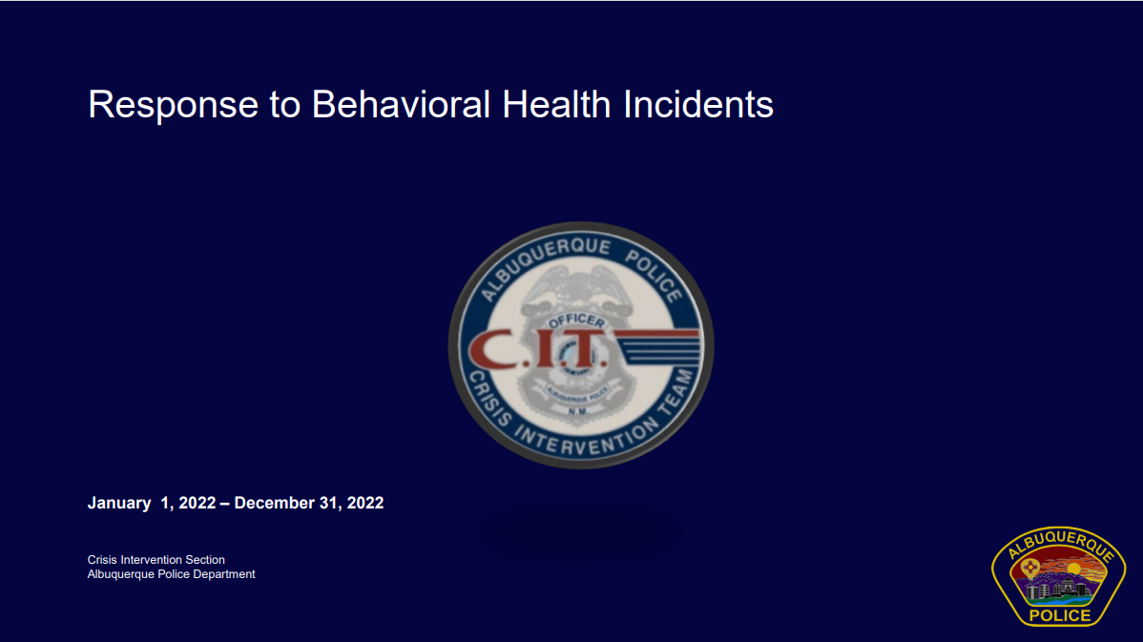
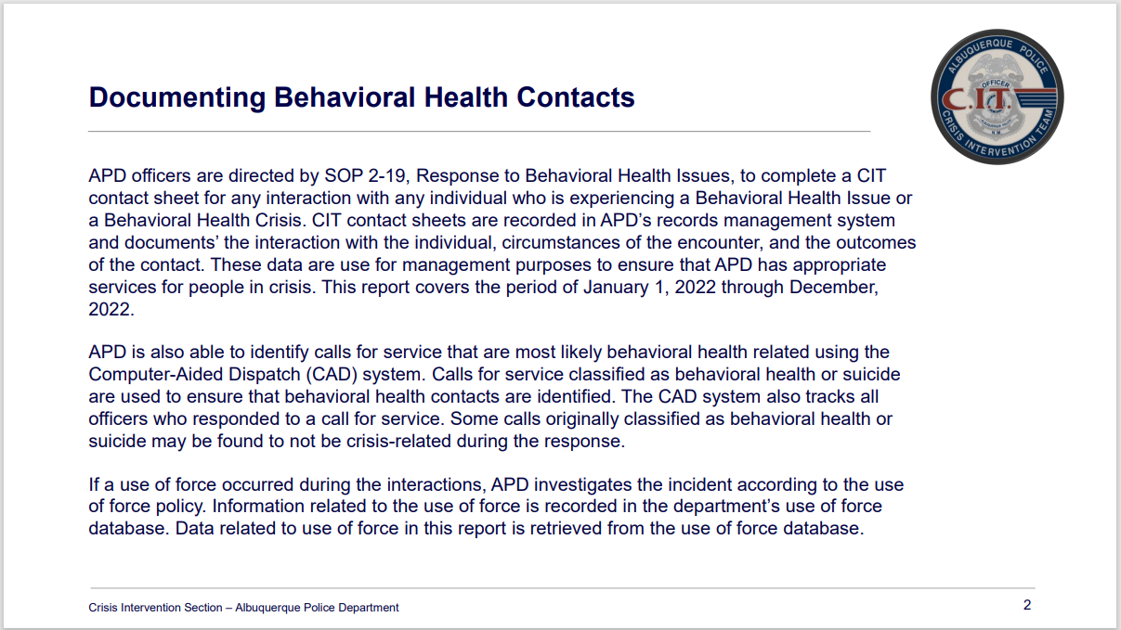
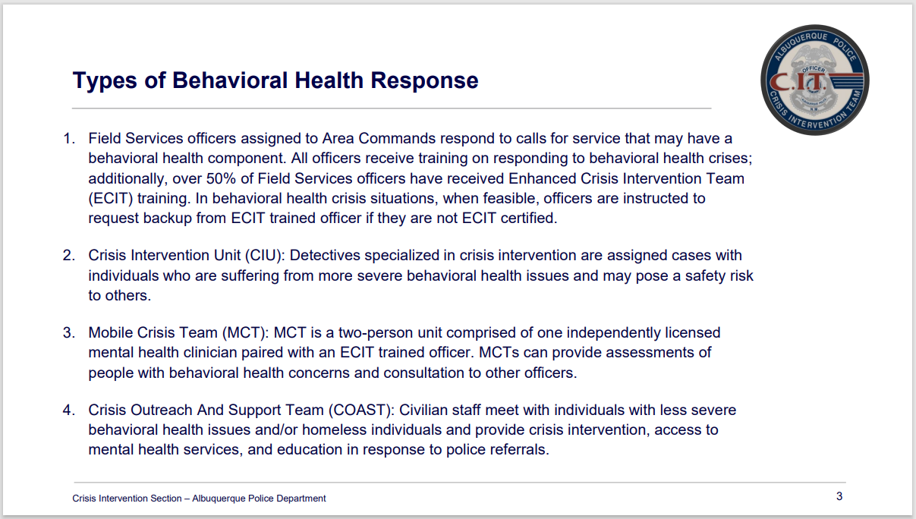

Dr. Dr. Vielehr Vielehr
The 2022 Use of Force Report should be available end of next week.

Albuquerque Community Safety (ACS) Update, Jasmine Desiderio
- Our data is currently posted on the Transparency website
- Since September 2021 the cumulative calls for service that ACS has responded to is over 37,000
- We have diverted over 22,000 calls from the police department.
- We have hired five (5) new responders; they completed their training last weekend and are currently in the field.
- We have a new academy starting July 31st with 10-12 new responders starting.
- We are potentially planning for the next training academy to be in October, so once that training is completed we will be able to say that we have filled most of our positions department-wide.
- We will be posting available positions online this week; we have a lot of admin positions which include two division managers.
- This year we did not get any new money.
- The council and the mayor have been asking ACS to go 24/7, so we are currently working on a shift bid with our responders. We are hoping that will be implemented as early as August 26th of this year.
- Our San Mateo and Catherine building is currently under construction.

Gibson Health Hub, Family & Community Services Update, Gilbert Ramirez and Doug Chaplin
- Today we went before the zoning hearing examiner because we were requesting a three-foot variance for the height of our fence.
- We were requesting a six-foot fence along our northern perimeter on Gibson with various entries; we wanted to offer a secure ingress and egress. It should be a fairly decorative fence. We will hear the results of our case within 15 days.
- We are near wrapping up the first phase of the new sheltering engagement center.
- We have begun construction under the medical sobering phase, and that is moving forward.
- We are having construction drawings on our medical respite piece and looking forward to that going out to bid and identifying a contractor that will come in and build that out.
- We are excited to have Dr. Azka Naru join us from the state with her leadership.
- We’ve engaged Dr. Shannon Bernardin, Ph.D., RN, CNL, and President of the National Sobering Collaborative in a contract to help us with our protocols and working criteria for folk’s acceptance and out, working with AFR. She has opened most of the sobering centers that are located in California

CIU, APD, and BSS Report and Update, Lt Gonzales, Sgt. Tinney
- We interviewed six officers for the CIU detective position; our new detective is Jeff Zamorano.
- Dr. Nicole Duranceaux, our new Director of Behavioral Sciences Services (BSS) will start on July 31st.
- An update on the shooting review, Commander Dietzel has advised that it is being reviewed by legal.
- We received a recommendation submission from the Valley CPC this week. It reads, “We recommend that the Albuquerque Police Department form a working group with the Albuquerque Community Safety Department (ACS) and any other organizations of expertise in behavioral management such as MHRAC to address the prevention of calls to APD to help manage those in a behavioral health crisis, specifically that the working group identified those individuals for whom they are a high volume of such calls. The need of these individuals and their families are caregivers with their goal to reduce the necessity of calls for police management and assistance.” They want a response by tomorrow.
- Detective Josh Isler finished his probation. The Bernalillo County Fire Department did a lot for him to receive his detective badge. Unfortunately, we were not able to collaborate with AFR on that.
- Detective Maxwell and Detective Isler attended the Moms Demand Action for Gun Violence event with the City. They talked about the Extreme Risk Firearm Protection Order (ERFPO). They also met with the Veterans Affairs Hospital (VA) about ERFPOs.
- The detectives will also be training others on how to use ERFPOs and ensure that they are not being misused and used appropriately.
- There was an article written by CNN recently talking about the Extreme Risk Firearm Protection Orders and how the APD CIU did a third of the ERFPOs that have been done in the state.

MHRAC Sub-Committee Report and Updates
Training Sub-Committee
We are meeting on Monday, July 24th.

Inforshare/Resources/Policy Sub-committee
No update on Inforshare. There was not a meeting in June.

MHRAC Final Discussion, Rachel Biggs (5 minutes)
We are talking about an ordinance, and codifying MHRAC is a really important function moving forward outside the CASA.

Meeting Transcribed by Fathom

Next meeting: August 15, 2023

